PROJECT STAGE -1 REPORT (CD753PC)
On
AI -BASED SMART UNDERGROUND CABLE FAULT DETECTION
AND REMOTE MONITORING
Submitted
in partial fulfilment of the requirements for the award of the degree of

Bachelor of Technology
in
Computer Science and Engineering (Data Science)

By
DETA JONAH RATAN
(23261A6717)
MADHAVARAM VINEEL
(24265A6702)
PASNOORI ABHINAY
(24265A6704)
Under the guidance of
Ms . A . SWAPNA

(Asst. Professor)

Department of Emerging Technologies
Mahatma Gandhi Institute of Technology (Autonomous)
(Affiliated to Jawaharlal Nehru Technological University Hyderabad) Kokapet(V), Gandipet(M),
Hyderabad. Telangana - 500075

2025-26
MAHATMA GANDHI INSTITUTE OF TECHNOLOGY(AUTONOMOUS)
(Affiliated to Jawaharlal Nehru Technological University Hyderabad)
GANDIPET, HYDERABAD – 500075, Telangana


CERTIFICATE

This is to certify that the project entitled – “AI-BASED SMART UNDERGROUND CABLE FAULT DETECTION AND REMOTE MONITORING ’’ is being submitted by DETA JONAH RATAN (23261A6717) , MADAVARAM VINEEL(24265A6702), PASNOORI ABHINAY (24265A6704) in partial fulfilment of the requirements for PROJECT STAGE-1 in COMPUTER SCIENCE AND ENGINEERING (DATA SCIENCE) is a record of Bonafide work carried out by them under our guidance and supervision .The results of the investigations enclosed in this report have been verified and found satisfactory.

HEAD OF THE DEPARTMENT
Prof. M. Ramabai
Head Department of ET
Department of ET

PROJECT GUIDE

Ms . A . SWAPNA
Asst. Professor, Dept of ET

DECLARATION

This is to certify that the work reported in this project titled “AI-BASED SMART UNDERGROUND CABLE FAULT DETECTION AND REMOTE MONITORING’’ is a record of work done by us in the Department of Emerging Technologies, Mahatma Gandhi Institute of Technology, Hyderabad.

No part of the work is copied from books/journals/internet and wherever the portion is taken, the same has been duly referred to in the text. The report is based on the work done entirely by us and not copied from any other source.

Deta Jonah Ratan
(23261A6717)
Madavaram Vineel
(24265A6702)
Pasnoori Abhinay
(24265A6704)

ACKNOWLEDGEMENT
The satisfaction that accompanies the successful completion of any task would be incomplete without the mention of people who made it possible because success is the abstract of hard work and perseverance, but steadfast of all is encouraging guidance. So, we acknowledge all those whose guidance and encouragement served as a beacon light and crowned my efforts with success.
We would like to express our sincere thanks to Prof G. Chandra Mohan Reddy, Principal MGIT, for providing the working facilities in college.
We wish to express our sincere thanks and gratitude to Dr. M. Rama Bai, Professor and HOD, Department of ET, MGIT, for all the timely support and valuable suggestions during the period of the project.
We are extremely thankful and indebted to our mentors Ms. A. Swapna Assistant Professor and Dr. D. Deepika Assistant Professor for their constant guidance , encouragement and moral support throughout the project.
Finally, I would also like to thank all the faculty and staff of ET Department who helped us directly or indirectly in completing this project.

Deta Jonah Ratan
(23261A6717)
Madavaram Vineel
(24265A6702)
Pasnoori Abhinay
(24265A6704)

TABLE OF CONTENTS

CERTIFICATE i
DECLARATION ii
ACKNOWLEDGEMENT iii
TABLE OF CONTENTS iv
LIST OF FIGURES v
LIST OF TABLES vi
ABSTRACT vii
1. INTRODUCTION 1
1.1 Problem Definition 2
1.2 Existing Applications 3
1.3 Proposed Application 4
1.3.1 Requirements Specifications 4
1.3.2 Software Requirements 5
1.3.3 Hardware Requirements 5
2. LITERATURE SURVEY 7
3. DESIGN METHODOLOGY 16
3.1 System Architecture 16
3.2 Hardware Design 17
3.3 Fault Detection and Distance Estimation 20
3.4 AI-Based Fault Diagnosis 21
3.5 Mobile Application Design 22
3.6 Data Logging and Predictive Health Monitoring 23
3.7 Implementation Steps 24
4. SAMPLE OUTPUTS 25
4.1 OLED Display Output 25
4.2 Mobile Application Outputs 25
4.3 Fault Event Log 26

LIST OF FIGURES
Figure 3.1 : Data Flow 16
Figure 3.2 : Layered System Architecture 17
Figure 3.3 : Hardware Block Diagram 18
Figure 3.4 : Cable Simulator and Fault Distance Estimation 19
Figure 3.5 : Flowchart of the Baseline Fault Detection Algorithm 21
Figure 3.6 : Machine Learning Pipeline 22
Figure 3.7 : Mobile Application and Predictive Health Monitoring 23
Figure 4.1: Normal Condition 25
Figure 4.2: Fault Detection 25
Figure 4.3: ML Diagnosis 26
Figure 4.4: Alert Notification 26

LIST OF TABLES
Table 2.1 : Literature Survey table 10
Table 3.1: Fault Detection and Distance Estimation Algorithm 20
Table 4.1: Fault Event Log 26

ABSTRACT
Underground power cables are widely used in urban and industrial power distribution because they are reliable and safe. When a fault occurs, though, its location is hard to identify, which leads to long outages, costly excavation, and slow repairs. Conventional methods such as loop tests and time-domain reflectometry are expensive, need skilled operators, and are used only after a failure has happened. This project presents an AI-enabled underground cable fault detection, distance estimation, and predictive health monitoring system built around the ESP32 microcontroller and IoT technology. A low-voltage, current-limited cable simulator, modelled as calibrated resistive sections, is used to create open-circuit and short-circuit faults safely at known distances. The ESP32 continuously monitors supply-side and load-side voltage, line current, and temperature near test connections using the high-accuracy TMP117 sensor. It detects faults with a baseline threshold algorithm and estimates the fault distance from calibrated electrical measurements based on Ohm’s law. Local status and fault details appear on an OLED display, and a buzzer gives immediate alerts. The sensor data is sent over Wi-Fi to a dedicated Android mobile application, where a trained machine-learning model runs in the background to classify the cable condition as normal, short circuit, open circuit, abnormal voltage, or overheating. Its predictions are compared with the baseline algorithm to evaluate how much the ML model improves diagnostic accuracy. The application shows live readings, graphs, fault type, estimated distance, and alerts, and keeps a timestamped event history. Historical trends are analysed to compute a cable health index that flags unusual behaviour and possible deterioration before a failure occurs. The proposed system offers a low-cost, scalable, and intelligent approach that shortens fault-location time, reduces unnecessary excavation, and supports predictive rather than reactive maintenance.

The system is developed as a laboratory prototype that uses Embedded C/C++ for the ESP32 firmware, Python for training the machine-learning model, and Android Studio for the mobile application. Its performance is evaluated by comparing estimated and actual fault distances, and by measuring the ML model’s accuracy, precision, recall, and F1-score against the baseline algorithm. The initial version leaves out GPS and GSM, which can be added in future versions for location tagging and SMS alerts. The proposed approach can be extended to real low-voltage distribution networks, campuses, and industrial plants to support smart-grid maintenance.

Keywords: Underground Cable Fault Detection, Fault Distance Estimation, ESP32, IoT, Machine Learning, TMP117, Mobile Application, Predictive Maintenance, Cable Health Monitoring

INTRODUCTION
Underground power cables are now widely used in urban distribution networks, industrial plants, campuses, and residential areas. Compared with overhead lines they are more reliable, safer, better protected from weather, and less visually intrusive. Because they are buried, though, faults are hard to find and fix. When a cable fails through insulation breakdown, moisture ingress, mechanical damage, ageing, or overheating, the exact fault location is usually unknown. Utility crews often have to excavate large sections of ground to find it, which takes time and money and extends supply outages.
Most cable faults fall into two groups. Open-circuit faults break the conductor’s continuity, so current stops flowing to the load. Short-circuit faults create an unintended low-resistance path between conductors or to ground, causing excessive current and possible damage to equipment. Both need fast detection and accurate location to keep downtime and repair costs low. Many faults also start slowly, as rising temperature at joints, gradual voltage drop, or irregular current. If these early signs are tracked, the cable can be inspected before it fails completely.
Conventional fault-location methods such as Murray loop tests, time-domain reflectometry (TDR), and manual inspection need specialised equipment and skilled operators. They are usually applied only after a failure has happened. They do not monitor the cable continuously, do not report its condition remotely, and do not predict deterioration. Low-cost embedded systems, wireless connectivity, and machine learning now make it possible to build intelligent monitoring systems that close these gaps.
This project presents an AI-enabled underground cable fault detection, distance estimation, and predictive health monitoring system built on the ESP32 microcontroller and IoT technology. The prototype uses a low-voltage, current-limited cable simulator in which cable length is represented by calibrated resistive sections, so open-circuit and short-circuit faults can be created safely at known distances. The system works out the fault distance from calibrated electrical measurements. It also monitors supply-side and load-side voltage, current, and temperature near test connections using the high-accuracy TMP117 digital temperature sensor.
A machine-learning model is trained on the collected sensor data to classify likely fault conditions, and its predictions are compared against a baseline threshold-based fault-detection algorithm. All readings, fault types, estimated distances, and system status are shown in real time on a Wi-Fi-connected web dashboard. Fault events are logged with timestamps for later analysis and report generation. A local buzzer and dashboard alerts notify the operator immediately when a fault or abnormal condition is detected. The system also analyses historical trends to flag unusual behaviour that may indicate cable deterioration, which moves maintenance from a reactive approach to a predictive one.
The initial version focuses on reliable sensing, accurate fault classification, distance estimation, and IoT-based monitoring. GPS-based location tagging and GSM-based SMS alerts are left for future development. The proposed system offers a low-cost, scalable, and intelligent approach to cable fault management. It can reduce fault-location time, cut unnecessary excavation, improve maintenance planning, and make the power distribution network more reliable.

Problem Definition
Underground cables keep power distribution reliable, but the way their faults are found and managed is still largely manual, reactive, and slow. Because the cable is buried, a fault cannot be seen directly. Maintenance teams usually learn about a failure only when the supply stops. Locating the fault then involves trial excavation or specialised test equipment run by skilled personnel. The result is long outages, high repair costs, wasted labour, and disruption to roads and the area around the cable.
The main problems this project addresses are:
- Difficulty in fault detection: Open-circuit and short-circuit faults in buried cables are not detected or identified automatically. Without continuous monitoring, a fault may go unnoticed until it causes a complete supply failure or damages equipment.
- Inaccurate fault location: Existing field methods such as the Murray loop test and time-domain reflectometry are expensive and need trained operators. They are not suited to low-cost or continuous use. Without a reasonable distance estimate, crews may have to excavate long stretches of cable to find a single fault.
- Lack of real-time electrical monitoring: Supply-side voltage, load-side voltage, and current are usually not monitored continuously. Voltage drops, overcurrent, sudden current changes, and near-zero current conditions are abnormal states that often come before or point to a fault, and they go unrecorded.
- Undetected thermal stress: Loose terminations, poor joints, and overloading raise the temperature at connection points. These hotspots speed up insulation ageing and can lead to failure, yet they are rarely monitored in low-cost systems.
- Rule-based detection limitations: Simple threshold-based methods can miss faults or raise false alarms when operating conditions change. A data-driven approach that learns patterns from several sensor inputs together could classify faults more reliably.
- No remote visibility or alerting: Without IoT connectivity, operators cannot see the live state of the cable or get immediate alerts, so the response to a fault is delayed.
- Absence of historical data and predictive insight: Fault events and sensor readings are seldom logged in a structured way. Without historical data, gradual deterioration cannot be spotted, so maintenance stays reactive and failures cannot be anticipated.
Problem Statement
The problem is to design and implement a low-cost, safe, intelligent system that can:
- automatically detect and classify open-circuit and short-circuit faults in a simulated low-voltage underground cable
- estimate the distance to the fault from calibrated electrical measurements
- continuously monitor voltage, current, and temperature for abnormal conditions
- apply machine learning to improve fault diagnosis over a baseline algorithm
- show live data and fault information on an IoT dashboard with local and remote alerts
- log fault events and analyse historical trends to give early warning of possible cable deterioration

Existing Applications
Conventional methods for locating faults in underground cables include the Murray and Varley loop tests, time-domain reflectometry (TDR), surge-generator (“thumper”) methods, sectionalising, and acoustic or tracer pinpointing. Loop tests use a bridge principle to locate short-circuit and ground faults, but they need manual balancing and a healthy return conductor. TDR gives the fault distance from reflected pulses, but the instruments are costly and the results need skilled interpretation. Surge and sectionalising methods work, but they are hazardous or destructive, slow, and labour-intensive.
Commercial fault-location vans and online monitoring systems combine several of these techniques and are accurate and reliable. However, they are very expensive, need trained operators, and are used mainly by utilities on high-voltage networks, usually after a fault has already occurred. Many academic prototypes take a low-cost route instead: cable length is modelled as a series resistor network, and an Arduino or a similar microcontroller estimates the fault distance using Ohm’s law, sometimes adding GSM-based SMS alerts or basic IoT upload. These prototypes usually detect only short-circuit faults, rely on fixed threshold logic, and do not monitor current or temperature.
Existing solutions are therefore either accurate but expensive and offline, or affordable but limited in what they can do. None of them combines fault detection, distance estimation, real-time monitoring of voltage, current, and temperature, machine-learning diagnosis, IoT visualisation, event logging, and predictive health monitoring in one low-cost platform. The proposed ESP32-based system is designed to fill that gap.

Proposed Application
The proposed system is an AI-enabled underground cable fault detection and health monitoring platform built around the ESP32 microcontroller. A low-voltage, current-limited cable simulator models the cable as calibrated resistive sections, so open-circuit and short-circuit faults can be created safely at known distances. Voltage sensors at the supply and load ends, a current sensor, and a TMP117 temperature sensor near the test connections continuously feed readings to the ESP32. The ESP32 detects faults and works out the fault distance from calibrated electrical measurements.
The machine-learning model is trained on the collected sensor data and runs on real-time sensor data. It takes the live supply-side voltage, load-side voltage, current, and temperature readings as input and classifies the cable condition as normal, open-circuit, short-circuit, or abnormal (overcurrent, voltage drop, or overheating). For each prediction it reports the fault type, a confidence level, the estimated fault distance, and the sensor values that triggered the decision, and these details update continuously on the dashboard. The model’s results are compared with a baseline threshold-based algorithm to show that it is more accurate. When a fault or abnormal condition is detected, a local buzzer sounds and an alert appears on the dashboard. Each event is logged with a timestamp, the sensor readings, the fault type, and the estimated distance, for later analysis.
The data is shown on a Wi-Fi-connected IoT dashboard that works on both mobile phones. The dashboard shows live voltage, current, and temperature readings with graphs, along with the Machine Learning predicted fault type, the estimated fault distance, system status, alerts, and the event history. Historical trends are analysed to flag unusual behaviour that may indicate cable deterioration, so inspection can be planned before a failure. The result is a low-cost, scalable, and intelligent move from reactive to predictive cable maintenance.

Requirements Specifications
The requirements specification lists the software and hardware needed to develop and run the AI-enabled underground cable fault detection and predictive health monitoring system.

Software Requirements
- Operating System: Windows 10/11 (64-bit) or Linux (Ubuntu 20.04 or later) for development
- Firmware IDE: Arduino IDE 2.x / VS Code with Platform IO (ESP32 board support)
- Mobile App IDE: Android Studio (latest stable version)
- Programming Languages: Embedded C/C++ (ESP32 firmware), Kotlin/Java (Android app), Python 3.8 or higher (ML model training)
- ML Frameworks and Libraries: NumPy, Pandas, Scikit-learn, TensorFlow / TensorFlow Lite (for model deployment), Matplotlib (data analysis)
- Communication Protocol: Wi-Fi with HTTP / MQTT for real-time data transfer between the ESP32 and the mobile app
- Database / Logging: SQLite (local storage on the mobile app) / Firebase (optional cloud logging)
- Mobile OS Support: Android 8.0 (Oreo) or higher
- Additional Tools: Jupyter Notebook (ML prototyping and visualisation), Serial Monitor (firmware debugging)

Hardware Requirements
- Embedded Hardware
  - Microcontroller: ESP32 development board (dual-core, built-in Wi-Fi)
  - Voltage Sensing: Voltage sensor modules / calibrated voltage-divider circuits (supply side and load side)
  - Current Sensing: INA219 / ACS712 current sensor module
  - Temperature Sensor: TMP117 high-accuracy digital temperature sensor (I2C)
  - Cable Simulator: Low-voltage, current-limited resistor network representing cable sections, with switches for creating faults
  - Alert Device: Buzzer (local alarm) and status LEDs
  - Power Supply: 5V / 12V DC regulated, current-limited supply
  - Miscellaneous: Breadboard/PCB, connecting wires, relays/switches, enclosure
- Computer Requirements for Development
  - Processor: Intel Core i5 (8th Gen or higher)
  - RAM: 8 GB or more (16 GB recommended for Android Studio and ML training)
  - Hard Disk: 256 GB SSD or more
  - Display: Minimum resolution of 1366 × 768 pixels
- Mobile Device Requirements (APK Deployment)
  - OS: Android 8.0 or higher
  - RAM: 3 GB or more
  - Storage: 100 MB free space or more
  - Connectivity: Wi-Fi enabled
  - Screen Type: Touch
  - Screen Size: 5 inches or more

LITERATURE SURVEY
[1] S. K. Satyanarayana, S. N. Chandra Shekhar, “Underground Cable Fault Detection Using IoT,” 2024 15th International Conference on Computing Communication and Networking Technologies (ICCCNT), IEEE, 2024.
An Arduino with current-measuring circuits, an ADC, relays, and an LCD detects and locates short-circuit faults. The fault data is sent over Wi-Fi to cloud storage for remote monitoring.
Link: https://doi.org/10.1109/ICCCNT61001.2024.10726118
[2] M. Jayachandran, K. N. Abdul Rani, A. Abd Wahab, “IoT-Based Smart Underground Cable Fault Detector,” 2024 IEEE 1st International Conference on Communication Engineering and Emerging Technologies (ICoCET), 2024.
An IoT-based detector finds cable faults and stores fault-zone information in a cloud database. The authors propose future ML/DL-based fault prediction.
Link: https://doi.org/10.1109/ICoCET63343.2024.10730067
[3] S. Jegadeesan et al., “An Intelligent ESP32-Driven Underground Cable Fault Detection and Self-Isolating Power Distribution Framework,” 2026 International Conference on Visual Analytics and Data Visualization (ICVADV), IEEE, 2026.
An ESP32 with voltage and current sensors classifies faults using thresholds, isolates the faulty section automatically through relays, and reports the location through GPS and an IoT cloud dashboard.
Link: https://doi.org/10.1109/ICVADV67766.2026.11470434
[4] S. Sudhagar, R. Marimuthu, “Determine the Exact Fault Location in Underground Cable: A Systematic Review,” IEEE Access, 2025.
A systematic review of conventional and intelligent techniques for detecting underground cable faults and finding their exact location.
Link: IEEE Xplore (DOI to be verified)
[5] Riadul Islam et al., “IoT-enabled Automatic Underground Cable Fault Detection and Monitoring System,” 2nd IEEE International Conference on Next-Generation Computing, IoT and Machine Learning (NCIM), 2025.
The work investigates locating underground cable faults by distance with a microcontroller, using GSM and GPS modules for remote reporting.
Link: IEEE Xplore (DOI to be verified)
[6] “Underground Cable Fault Detection and Monitoring System,” 2025 International Conference for Emerging Technology (INCET), IEEE, 2025.
A system for detecting underground cable faults and continuously monitoring the cable’s condition.
Link: https://doi.org/10.1109/INCET64471.2025.11140826
[7] “Underground Cable Fault Location Detector using GPS and GSM Module,” 2025 International Conference on Computing Technologies (ICOCT), IEEE, 2025.
A microcontroller monitors cable resistance to find the fault location. GPS gives its coordinates and GSM sends them remotely.
Link: https://doi.org/10.1109/ICOCT64433.2025.11118791
[8] K. H. Ali, A. A. Aboushady, S. Bradley, M. E. Farrag, S. A. Abdel Maksoud, “An Industry Practice Guide for Underground Cable Fault-Finding in the Low Voltage Distribution Network,” IEEE Access, 2022.
The paper analyses fault-finding techniques for low-voltage underground cables and the practical procedures utilities use to locate faults.
Link: https://doi.org/10.1109/ACCESS.2022.3186352
[9] Zhou et al., “Review of recent research towards power cable life cycle management,” High Voltage (IET), 2017.
The authors review cable condition monitoring, diagnosis, and life assessment across the cable life cycle. They conclude that the full potential of condition monitoring has not yet been realised.
Link: https://ietresearch.onlinelibrary.wiley.com/doi/10.1049/hve.2017.0037
[10] Choudhary et al., “A Review of Aging Models for Electrical Insulation in Power Cables,” Energies (MDPI), 2022.
The paper reviews single-stress and multi-stress ageing models for cable insulation. It notes that no dependable model for estimating real-world degradation exists yet.
Link: https://www.mdpi.com/1996-1073/15/9/3408
[11] A. Morales, N. Purushothaman, “A review on partial discharge diagnosis in cables: Theory, techniques, and trends,” Measurement (Elsevier), vol. 216, 2023.
The paper surveys partial discharge (PD) detection techniques by sensor type. It discusses their limitations as early indicators of insulation deterioration.
Link: https://www.sciencedirect.com/science/article/abs/pii/S0263224123004463
[12] J. Tao, S. U. Rehman, R. Ali, S. A. Raza, “Advancement and challenges: A review of power cable aging monitoring and diagnostic techniques,” Renewable and Sustainable Energy Reviews, vol. 222, 2025.
The review links ageing mechanisms with monitoring methods: PD, sheath current, dielectric loss, fibre-optic, and thermal monitoring. It highlights ML for predictive maintenance.
Link: https://www.sciencedirect.com/science/article/abs/pii/S1364032125006434
[13] K. Emdadi, M. Gandomkar, A. Aranizadeh, B. Vahidi, M. Mirmozaffari, “Overview of Monitoring, Diagnostics, Aging Analysis, and Maintenance Strategies in High-Voltage AC/DC XLPE Cable Systems,” Sensors (MDPI), vol. 25, 2025.
The paper covers PD sensing, XLPE ageing, and ML-based predictive maintenance. It identifies a gap in integrated diagnostic and ageing analysis.
Link: https://doi.org/10.3390/s25227096
[14] H. Kumar, K. Kauhaniemi, M. Elmusrati, M. Shafiq, “Emerging Technologies based Use Case Development for Condition Monitoring and Predictive Maintenance of MV Cables,” IEEE PES ISGT-LA, 2023.
The paper proposes use cases that combine sensors, data analytics, and ML for condition monitoring and predictive maintenance of medium-voltage cables.
Link: https://doi.org/10.1109/ISGT-LA56058.2023.10328309
[15] Q. Shao, S. Fan, Z. Zhang, F. Liu, Z. Fu, P. Lv, Z. Mu, “Artificial Intelligence in Cable Fault Detection and Localization: Recent Advances and Research Challenges,” Energies (MDPI), vol. 18, 2025.
The paper reviews ML and deep learning methods for detecting and locating cable faults. It outlines challenges such as data scarcity and real-world validation.
Link: https://doi.org/10.3390/en18143662
[16] Said et al., “Deep Learning-Based Fault Classification and Location for Underground Power Cable of Nuclear Facilities,” IEEE Access, 2022.
A 1D-CNN combined with a binary SVM classifies and locates faults in simulated 11 kV underground cables with high accuracy.
Link: https://ieeexplore.ieee.org/document/9810250/
[17] Zhao Hong-shan et al., “A hierarchical diagnosis method of cable aged segment based on transfer function,” IET Science, Measurement & Technology, 2022.
A transfer-function model with a sparse autoencoder and a CNN finds where aged cable segments are, online and without supply outages.
Link: https://doaj.org/article/dd1c79631612413e98d5c811ee0c5cb2
[18] H. Livani, C. Y. Evrenosoglu, “A Fault Classification and Localization Method for Three-Terminal Circuits Using Machine Learning,” IEEE Transactions on Power Delivery, vol. 28, no. 4, pp. 2282–2290, 2013.
Machine-learning classifiers identify the fault type and the faulted section in three-terminal circuits. This is an early example of ML used for fault classification.
Link: https://doi.org/10.1109/TPWRD.2013.2272936

Table 2.1 : Literature Survey table
S.No | Author(s) | Title | Year | Journal/ Conference | Methodology/ Concept Used | Merits | Demerits
1 | S. K. Satyanarayana, S. N. Chandra Shekhar | Underground Cable Fault Detection Using IoT | 2024 | IEEE ICCCNT | Arduino, current sensing, ADC, relay, LCD, Wi-Fi cloud | Remote cloud storage of fault data | Short-circuit faults only; no ML
2 | M. Jayachandran, K. N. Abdul Rani, A. Abd Wahab | IoT-Based Smart Underground Cable Fault Detector | 2024 | IEEE ICoCET | IoT fault detection with cloud database | Fault-zone history stored in cloud | ML/DL prediction only proposed, not implemented
3 | S. Jegadeesan et al. | An Intelligent ESP32-Driven Underground Cable Fault Detection and Self-Isolating Power Distribution Framework | 2026 | IEEE ICVADV | ESP32, V/I sensors, threshold classification, relays, GPS, IoT dashboard | Automatic isolation of faulty section | Threshold-based; no temperature or predictive analysis
4 | S. Sudhagar, R. Marimuthu | Determine the Exact Fault Location in Underground Cable: A Systematic Review | 2025 | IEEE Access | Systematic review of conventional and intelligent methods | Broad comparison of location techniques | Review only; no implementation
5 | Riadul Islam et al. | IoT-enabled Automatic Underground Cable Fault Detection and Monitoring System | 2025 | IEEE NCIM | Microcontroller distance localisation with GSM and GPS | Remote alert with location | No ML; no temperature monitoring
6 | — | Underground Cable Fault Detection and Monitoring System | 2025 | IEEE INCET | Fault detection and monitoring system | Continuous monitoring | Limited intelligence; no health prediction
7 | — | Underground Cable Fault Location Detector using GPS and GSM Module | 2025 | IEEE ICOCT | Microcontroller, cable-resistance monitoring, GPS, GSM | Remote communication of fault location | Rule-based only; no data analytics
8 | K. H. Ali, A. A. Aboushady, S. Bradley, M. E. Farrag, S. A. Abdel Maksoud | An Industry Practice Guide for Underground Cable Fault-Finding in the Low Voltage Distribution Network | 2022 | IEEE Access | Analysis of LV fault-finding techniques and procedures | Practical, industry-based guidance | No automated or IoT solution
9 | Zhou et al. | Review of recent research towards power cable life cycle management | 2017 | High Voltage (IET) | Review of condition monitoring and life assessment | Covers the full cable life cycle | Review only; no implementation
10 | Choudhary et al. | A Review of Aging Models for Electrical Insulation in Power Cables | 2022 | Energies (MDPI) | Single and multi-stress insulation ageing models | Basis for cable life estimation | No dependable real-world model
11 | A. Morales, N. Purushothaman | A review on partial discharge diagnosis in cables: Theory, techniques, and trends | 2023 | Measurement (Elsevier) | PD detection techniques by sensor type | Early sign of insulation deterioration | Costly sensors; complex analysis
12 | J. Tao, S. U. Rehman, R. Ali, S. A. Raza | Advancement and challenges: A review of power cable aging monitoring and diagnostic techniques | 2025 | Renewable and Sustainable Energy Reviews | PD, sheath current, dielectric loss, thermal monitoring, ML | Links ageing causes to monitoring | EMI, sensor and data challenges
13 | K. Emdadi, M. Gandomkar, A. Aranizadeh, B. Vahidi, M. Mirmozaffari | Overview of Monitoring, Diagnostics, Aging Analysis, and Maintenance Strategies in HV AC/DC XLPE Cable Systems | 2025 | Sensors (MDPI) | PD sensing, XLPE ageing, ML predictive maintenance | Up to date; covers predictive maintenance | HV only; integration gap
14 | H. Kumar, K. Kauhaniemi, M. Elmusrati, M. Shafiq | Emerging Technologies based Use Case Development for Condition Monitoring and Predictive Maintenance of MV Cables | 2023 | IEEE PES ISGT-LA | Sensors, analytics and ML use cases | Practical predictive-maintenance use cases | Conceptual; limited validation
15 | Q. Shao, S. Fan, Z. Zhang, F. Liu, Z. Fu, P. Lv, Z. Mu | Artificial Intelligence in Cable Fault Detection and Localization: Recent Advances and Research Challenges | 2025 | Energies (MDPI) | Review of ML and deep learning for cable faults | Broad view of AI techniques | No hardware implementation
16 | Said et al. | Deep Learning-Based Fault Classification and Location for Underground Power Cable of Nuclear Facilities | 2022 | IEEE Access | 1D-CNN with binary SVM | High classification and location accuracy | Simulation-based; heavy computation
17 | Zhao Hong-shan et al. | A hierarchical diagnosis method of cable aged segment based on transfer function | 2022 | IET Science, Measurement & Technology | Transfer function with sparse autoencoder and CNN | Online detection; no outage | Complex; needs special measurement
18 | H. Livani, C. Y. Evrenosoglu | A Fault Classification and Localization Method for Three-Terminal Circuits Using Machine Learning | 2013 | IEEE Trans. Power Delivery | ML classifiers for fault type and section | Early proof of ML for faults | For transmission lines, not cables

DESIGN METHODOLOGY
The system is designed and built in stages. Each stage handles one function (sensing, fault detection, distance estimation, AI diagnosis, communication, or health monitoring), and the stages are then integrated into one working prototype. This section covers the system architecture, the hardware design, the software design, and how the machine-learning and predictive-monitoring parts work.

System Architecture
The system has four layers:
- Sensing Layer: A low-voltage, current-limited cable simulator with voltage sensors at the supply and load ends, a current sensor, and a TMP117 temperature sensor near the test connections.
- Processing Layer: The ESP32 microcontroller reads all sensors, filters the signals, runs the baseline fault-detection algorithm and the trained ML model, and calculates the fault distance.
- Communication Layer: The ESP32 sends live data, fault results, and alerts over Wi-Fi to the mobile application using MQTT/HTTP.
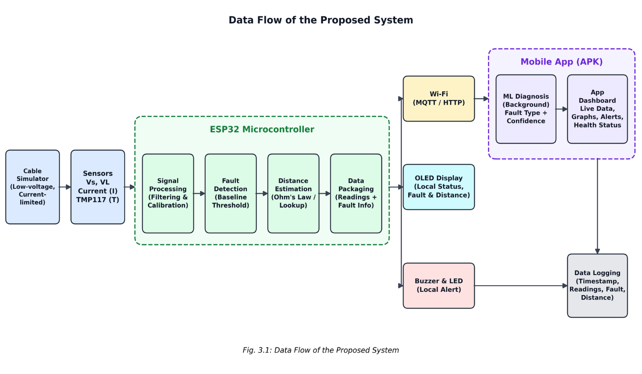
- Application Layer: The Android mobile application (APK) shows live readings, graphs, fault type, fault distance, alerts, event history, and the cable health status. A local buzzer gives an immediate alarm at the hardware end.
Figure 3.1 : Data Flow
The layered architecture of the proposed system is shown in Figure 3.2. The sensing layer collects electrical and thermal data from the cable simulator. The processing layer on the ESP32 filters and calibrates the signals, detects faults, and estimates the fault distance. The communication layer sends the data over Wi-Fi using MQTT/HTTP and drives the local OLED, buzzer, and LEDs. The application layer on the Android app runs the ML diagnosis, shows the dashboard, raises alerts, and maintains the event log and health index.
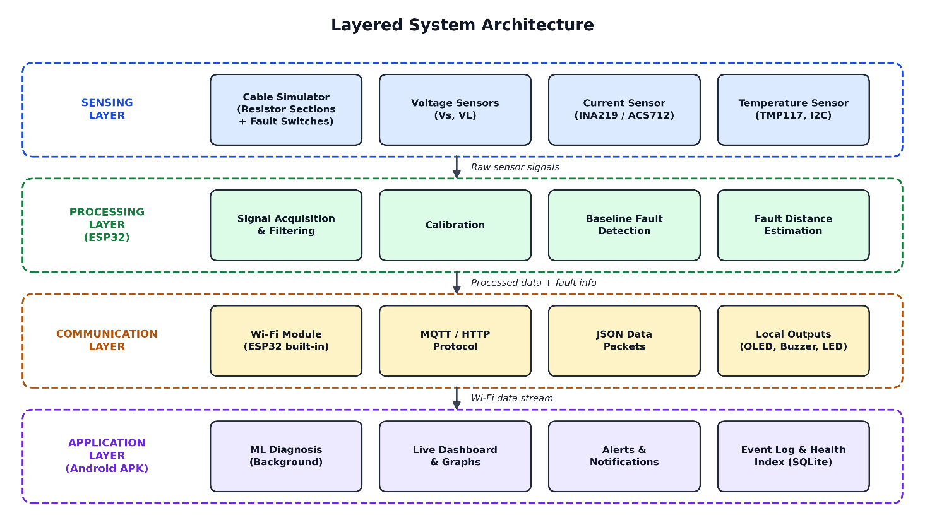
Figure 3.2 : Layered System Architecture

Hardware Design
The hardware block diagram is shown in Figure 3.3. The ESP32 microcontroller is the central unit. It reads the voltage sensors through its ADC, and the INA219 current sensor and TMP117 temperature sensor through the I2C bus. It drives the OLED display over I2C, and the buzzer and status LEDs through GPIO pins. Its built-in Wi-Fi links it to the Android mobile application. A regulated, current-limited DC supply powers the system and the cable simulator.
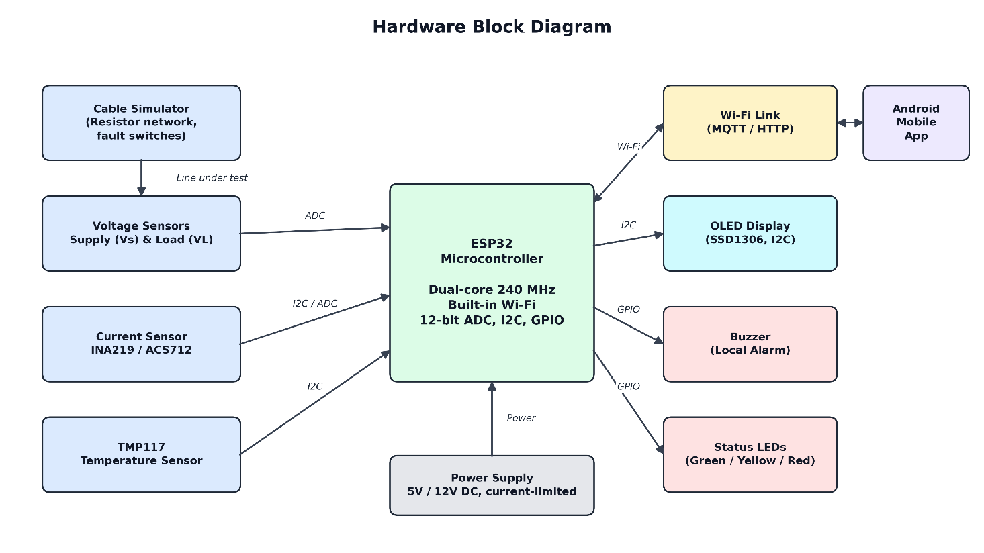
Figure 3.3 : Hardware Block Diagram
- Cable Simulator
- The underground cable is modelled as a series of resistors. Each resistor represents a fixed length of cable, for example 1 km per section. A current-limited low-voltage DC supply (5V/12V) is applied at the sending end.
Toggle switches at each section create faults safely:
- Short-circuit fault: A switch connects the line conductor to the return conductor at the selected section.
- Open-circuit fault: A switch breaks the conductor’s continuity at the selected section.
The cable simulator circuit is shown in Figure 3.4. Each 1 km section of cable is represented by a 100 Ω resistor in both the line and return conductors. Closing switch SWk shorts the two conductors at k km. The ESP32 measures the sending-end voltage and current to calculate the loop resistance. From that resistance it estimates the fault distance using Ohm's law.
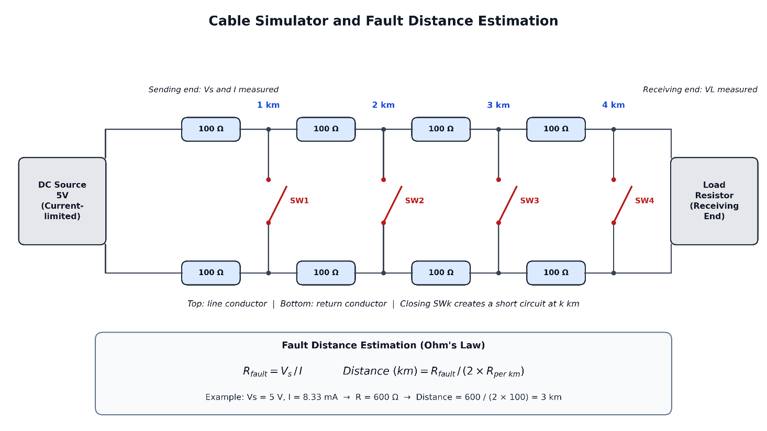
Figure 3.4 : Cable Simulator and Fault Distance Estimation
b) Voltage Monitoring
Calibrated voltage-divider or voltage-sensor modules measure the supply-side voltage (V_s) and the load-side voltage (V_L). The drop between them shows the cable condition and helps identify an abnormal voltage drop or open circuit.
c) Current Monitoring
An INA219/ACS712 current sensor measures the line current (I). The current pattern shows the condition:
- Overcurrent points to a short circuit.
- Near-zero current points to an open circuit.
- Sudden variation points to an intermittent or developing fault.
d) Temperature Monitoring
The TMP117 digital temperature sensor (±0.1 °C accuracy, I2C interface) is placed near the test connections and joints. It detects abnormal heating caused by loose contacts, high resistance, or overload.
e) Alert Unit
A buzzer and status LEDs give a local indication of the system state:
- Green: normal.
- Yellow: warning.
- Red with buzzer: faul

Fault Detection and Distance Estimation
Baseline Fault-Detection Algorithm
A rule-based algorithm compares each reading against calibrated thresholds:
Table 3.1: Fault Detection and Distance Estimation Algorithm
Condition | Rule | Result
Normal | V_L ≈ expected, I within range, T normal | Healthy
Short Circuit | I > I_max and V_L drops sharply | Short-circuit fault
Open Circuit | I ≈ 0 and V_L ≈ 0 | Open-circuit fault
Abnormal Voltage | (V_s − V_L) > ΔV_limit | Voltage-drop warning
Overheating | T > T_limit or rapid temperature rise | Thermal warning
The flowchart of the baseline fault detection algorithm is shown in Figure 3.5. In every cycle, the ESP32 reads the filtered sensor values and checks them in order for a short circuit, an open circuit, an abnormal voltage drop, and overheating. When a fault or warning is detected, it triggers the buzzer, LEDs, and OLED display. It sends a data packet to the mobile application on every cycle, including during normal operation, and then waits for the next sample.
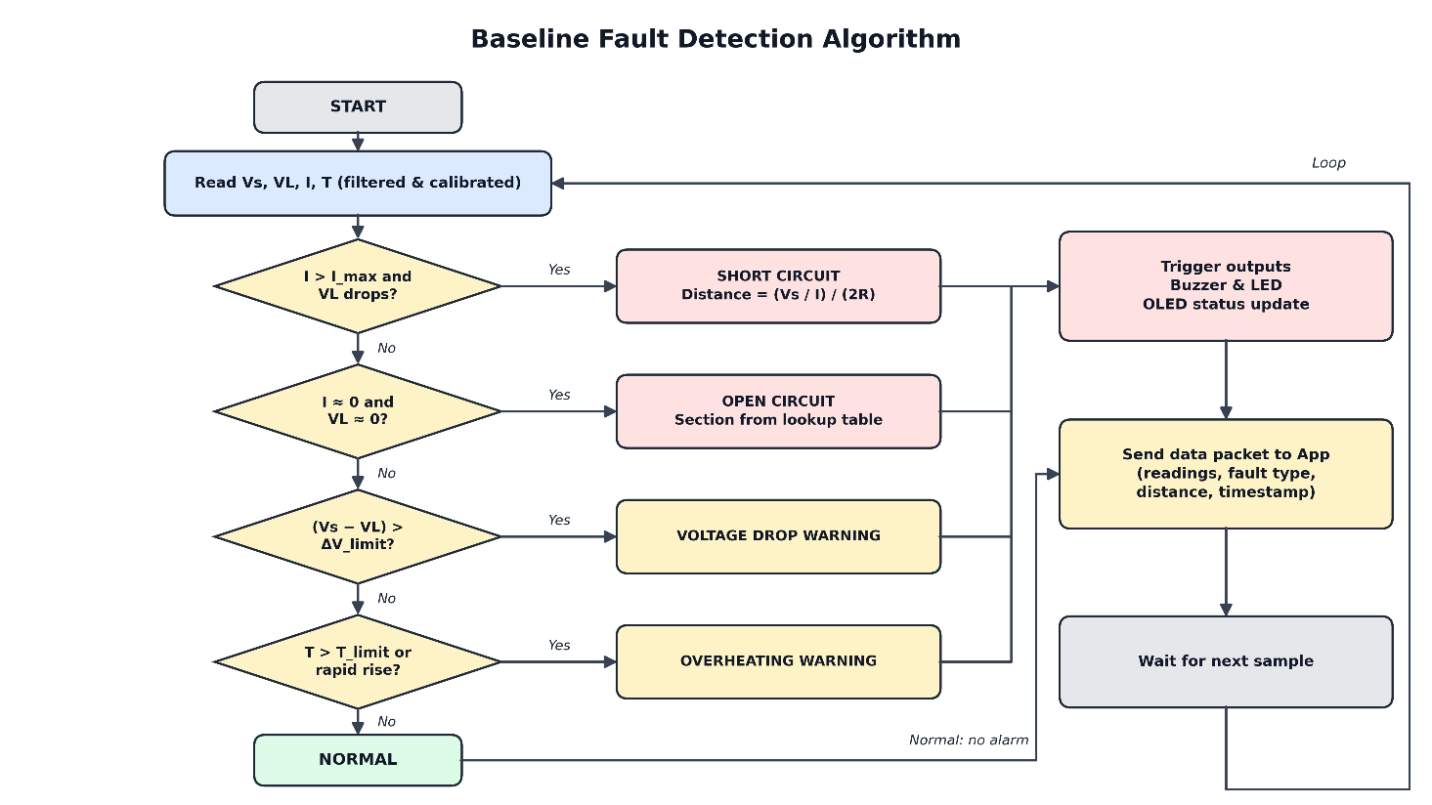
Figure 3.5 : Flowchart of the Baseline Fault Detection Algorithm

Fault Distance Estimation (Ohm’s Law Method)
In a short circuit, the loop resistance measured from the sending end is proportional to the distance to the fault:
R_fault = V_s / I
Distance (km) = R_fault / (2 × R_per_km)
The factor 2 accounts for the go and return conductors. R_per_km is the calibrated resistance of one cable section.
For an open circuit, the fault section is found from calibrated measurements stored in a lookup table. Each fault position gives a distinct electrical signature, recorded during calibration.
Calibration
- Create faults at every known section.
- Record the measured values.
- Fit a calibration curve or lookup table that corrects for sensor offsets, contact resistance, and ADC non-linearity. This improves distance accuracy.

AI-Based Fault Diagnosis
The machine learning pipeline is shown in Figure 3.6. Offline, labelled sensor data is used to extract features, train candidate models, and evaluate them. The best model is then exported in TensorFlow Lite format. This model is deployed in the Android application, where it runs as a background service on live data received from the ESP32. Its predictions are compared with the baseline threshold algorithm to evaluate how much the ML model improves accuracy.
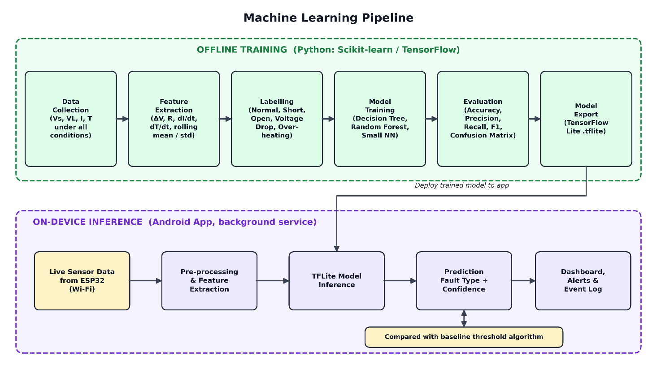
Figure 3.6 : Machine Learning Pipeline
The ML model takes real-time sensor data as input and classifies the cable condition.
Step 1: Data Collection
Readings of V_s, V_L, I, and T are recorded under normal operation and under each fault and abnormal condition, at different fault positions and load levels.
Step 2: Feature Extraction
Each sample is described by these features:
- V_s, V_L, I, T
- voltage drop (V_s − V_L)
- calculated resistance (V_s/I)
- rate of change of current (dI/dt)
- rate of change of temperature (dT/dt)
- rolling mean and standard deviation
Step 3: Labelling
Each sample is labelled with one of five classes: Normal, Short Circuit, Open Circuit, Abnormal Voltage, or Overheating.
Step 4: Model Training
Lightweight classifiers are trained in Python (Scikit-learn/TensorFlow) on an 80:20 train-test split: Decision Tree, Random Forest, and a small Neural Network.
Step 5: Deployment
The best-performing model is converted to C code (TensorFlow Lite Micro / exported tree logic) and runs on the ESP32. It takes live sensor readings as input and outputs the predicted fault type with a confidence score.
Step 6: Comparison
The ML predictions are compared with the baseline threshold algorithm using accuracy, precision, recall, F1-score, and a confusion matrix.

Mobile Application Design
The internal structure of the mobile application is shown in Figure 3.7. A data receiver accepts the ESP32 data stream and passes it to the ML diagnosis service and the local database. The predictive health module analyses the stored history for trends and anomalies and calculates a health index from 0 to 100. The results appear on four screens: Dashboard, Fault Details, Alerts, and Health Status.
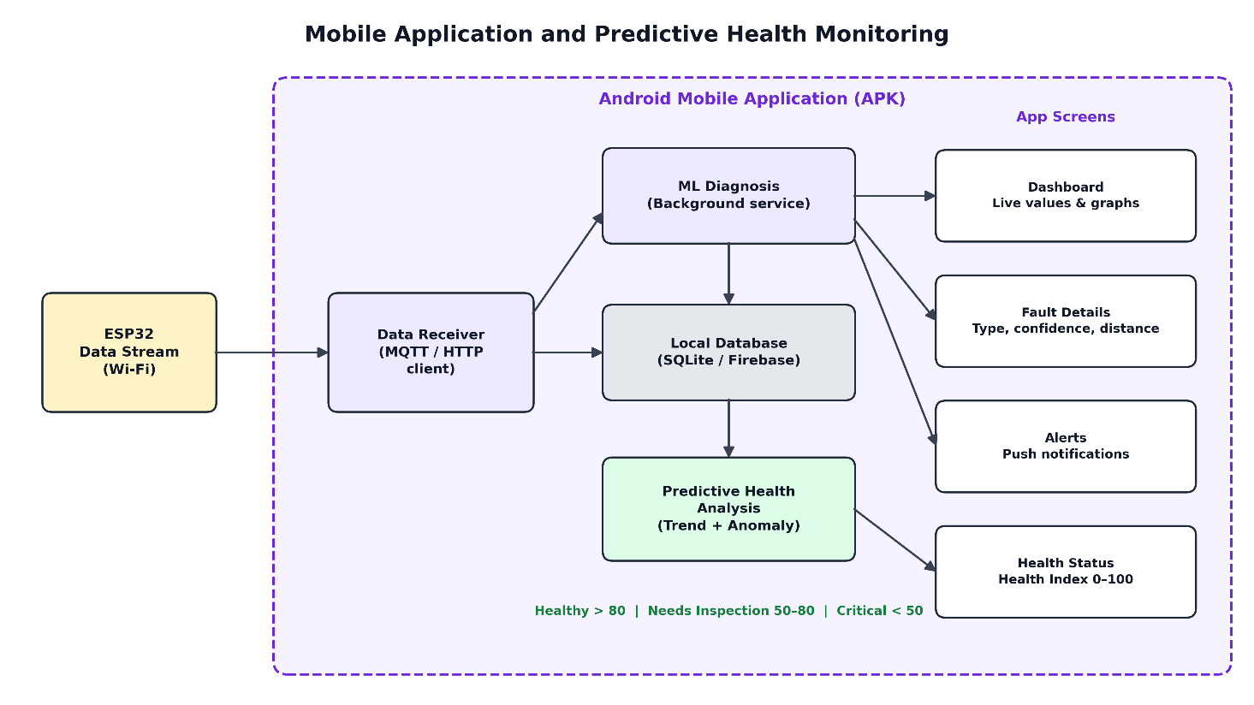
Figure 3.7 : Mobile Application and Predictive Health Monitoring
The Android application connects to the ESP32 over Wi-Fi and has these screens:
- Dashboard: Live V_s, V_L, I, and T values with system status
- Graphs: Real-time trend plots of voltage, current, and temperature
- Fault Details: ML-predicted fault type, confidence, estimated fault distance, and timestamp
- Alerts: Push notifications for faults and abnormal conditions
- Event History: A log of all fault events, stored in SQLite with optional Firebase backup
- Cable Health: A health score and trend-based maintenance recommendation

Data Logging and Predictive Health Monitoring
Every reading and fault event is stored with a timestamp. Predictive health monitoring then analyses the history:
- Baseline: A normal operating baseline is learned for each parameter.
- Trend analysis: Moving averages and rate-of-change analysis detect gradual drifts, for example a slowly rising temperature or resistance.
- Anomaly detection: A statistical method (z-score / exponentially weighted moving average) or an Isolation Forest model flags readings that deviate from the baseline.
- Health Index: A cable health score from 0 to 100 combines these indicators into three bands:
  - Healthy: above 80
  - Needs Inspection: 50 to 80
  - Critical: below 50

Implementation Steps
- Design and assemble the cable simulator and sensor circuits.
- Develop ESP32 firmware for sensor acquisition, filtering, and calibration.
- Implement the baseline fault-detection and distance-estimation algorithms.
- Collect and label the dataset under different fault conditions.
- Train, evaluate, and deploy the ML model on the ESP32.
- Develop the Android application and the Wi-Fi communication.
- Implement alerts, data logging, and predictive health analysis.
- Integrate and test the full system, and compare the ML results with the baseline.

SAMPLE OUTPUTS
This section shows the expected outputs from each part of the system: the ESP32 serial monitor, the OLED display, the mobile application, the event log, and the evaluation results. The values are sample values for a 5 V current-limited cable simulator. Each cable section represents 1 km, with R_per_km = 100 Ω.

OLED Display Output
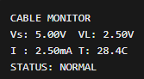
- Normal condition:

Figure 4.1: Normal Condition

- Fault condition:
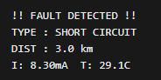
Figure 4.2: Fault Detection

Mobile Application Outputs
a) Live Dashboard: shows real-time V_s, V_L, I, and T values, with live graphs of voltage, current, and temperature. The status indicator is green for normal, yellow for warning, and red for fault.
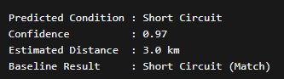
b) ML Diagnosis Output (background model):
Figure 4.3: ML Diagnosis
c) Alert Notification:
Figure 4.4: Alert Notification

Fault Event Log
Table 4.1: Fault Event Log
S.No | Timestamp | V_s (V) | V_L (V) | I (mA) | T (°C) | Fault Type (ML) | Distance (km) | Alert
1 | 24-10-2026 10:15:04 | 4.98 | 0.02 | 8.30 | 29.1 | Short Circuit | 3.0 | Yes
2 | 24-10-2026 10:16:20 | 5.00 | 0.00 | 0.01 | 28.6 | Open Circuit | 2.0 | Yes
3 | 24-10-2026 10:30:45 | 5.00 | 2.10 | 2.85 | 30.2 | Abnormal Voltage Drop | — | Warning
4 | 24-10-2026 11:02:10 | 5.00 | 2.48 | 2.52 | 52.6 | Overheating | — | Warning

